**Online Safety Newsletter**

**March 2025**

**The impact of smartphones**



There is a growing concern on how excessive use of smartphones can affect our children.

In addition to the effects of seeing inappropriate content online, the risk of cyberbullying and grooming, it is important that we also highlight the effects of smartphone use on our children’s mental health.

If your child is using a smartphone then please try to ensure they maintain a healthy screentime limit.

According to King’s College London, “two new studies of smartphone habits in teenagers have identified links between problematic smartphone use and depression, anxiety and insomnia.” You can read more about these studies here:

<https://www.kcl.ac.uk/news/teens-with-problematic-smartphone-use-are-twice-as-likely-to-have-anxiety-and-many-are-eager-to-cut-down>

Compass have published an article as well on what effects mobile phones have on children here:

<https://www.compass-uk.org/services/compass-changing-lives/what-effects-do-mobile-phones-have-on-children-and-young-peoples-mental-health/>

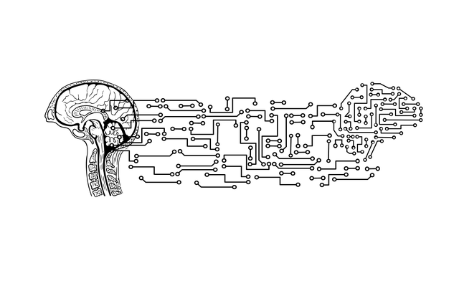**Artificial Intelligence (AI)**

**What is AI?**

AI is when a computer/machine can learn and perform tasks like a human. Its popularity continues to increase, and examples include:

* **Virtual assistants** like Alexa and Siri.
* **Chatbots** such as ChatGPT and My AI from Snapchat

**Potential Risks of AI?**

* **Chat apps -** A simple search of “AI Chat” within the App store highlights the number of apps already available and just scrolling through, you can see that they are not suitable for children with many rated as 17+.
* **Image manipulation –** there are AI tools that can be used to digitally remove clothes from photos, which clearly raises serious safeguarding and privacy concerns.
* **Deepfakes** – there are also AI tools that create realistic, fake videos which can be used to spread misinformation or cause harm.

Child Rescue Coalition discuss the dangers in more detail here:

<https://childrescuecoalition.org/educations/the-dark-side-of-ai-risks-to-children/>

**How can I protect my child?**

As always, to keep your child safe online, it is important to:

* Develop your child’s digital literacy by highlighting the risks of AI and showing them how important it is to verify what they see online.
* Set up appropriate parental controls on their devices/ broadband.
* Chat to your child regularly and ensure your child knows that they should talk to you or another trusted adult if anything concerns them.

**Further information**

For further information, the NSPCC and Internet Matters provide useful guides on their websites:

* <https://www.nspcc.org.uk/about-us/news-opinion/2025/artificial-intelligence-safety-tips-for-parents>
* <https://www.internetmatters.org/resources/parent-guide-to-artificial-intelligence-ai-tools/>

*Users of this guide do so at their own discretion. No liability is entered into. Current as of the date released 01.03.25. The inclusion of any links does not imply any affiliation with or endorsement of the linked websites, documents, or videos, nor are we claiming any ownership or copyright in the content of the linked materials.*

**Talk PANTS with the NSPCC**

Talk PANTS was developed to help you have conversations with your child to help them understand that their body belongs to them.

You can find out more here as well as a further link to helpful questions:

<https://www.nspcc.org.uk/keeping-children-safe/support-for-parents/pants-underwear-rule/>

**TikTok**

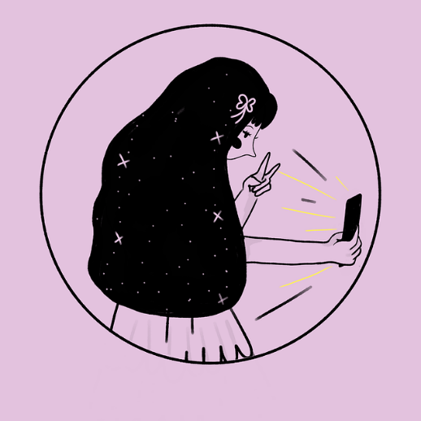**You must be over 13 years of age to use TikTok.** TikTok is a social media platform for sharing and watching short video clips. Some of the videos may not be appropriate for your child to view and there is also the risk of strangers contacting your child. If your child is using TikTok then make sure appropriate security/privacy settings are applied.

**Account set up**

It is important that when setting up an account, your child enters their real date of birth as accounts are tailored by age e.g., Direct Messaging is disabled for accounts aged 13-15. In addition, advertisements are tailored by age. By default, accounts for people under 16 are set to private and we would recommend keeping it as this. This means your child must approve follower requests. You can read more about the other settings available, such as switching off comments and restricted mode here: <https://support.tiktok.com/en/account-and-privacy/account-privacy-settings/privacy-and-safety-settings-for-users-under-age-18>

**LEGO Arcade**

Are you looking for games for your child to play online? LEGO have a selection of fun games including Lego Ninjago and Lego Friends:

<https://kids.lego.com/en-gb/arcade>

**Family Pairing**

This allows you to link your own account to your child’s account. You can then set controls such as restricted mode. You can find out more here: <https://support.tiktok.com/en/safety-hc/account-and-user-safety/family-pairing>

**Inappropriate content, themes and challenges on TikTok**

Whilst against TikTok’s guidelines, explicit and inappropriate content can be found on this platform, for example nudity/sexual content and hate speech. Some of the songs available to lip sync to may contain inappropriate lyrics or adult themes. We often see viral challenges on social media, some of which can be dangerous. If your child is using TikTok, chat to them regularly about what they are viewing.

**Stars Messenger App**

The Stars Messenger App is rated as 4+ on the App store. It is a free messaging and video app designed for children to use. Users need their friend’s username as well as their unique private Friend Code to add each other. There is also an optional Parent View available for a monthly charge.

South West Grid for Learning provide a full guide to staying safe on this app as well as safety considerations:

<https://swgfl.org.uk/magazine/a-guide-to-staying-safe-with-the-stars-messaging-app/>

**Stranger contact**

Talk to your child about who is following them online and ensure that they understand that people may not be who they say they are when online. It is important that children understand not to share personal information.

**Refresh your feed**

You can refresh your “For You” feed to update the content recommended:

<https://support.tiktok.com/en/account-and-privacy/account-privacy-settings/refresh-your-for-you-feed>

**Blocking and Reporting**

Ensure your child knows how to use the safety features available to them, including how to report comments, direct messages and another user.

**Further information**

* <https://parentzone.org.uk/article/tiktok>
* <https://safeguarding.thekeysupport.com/factsheets-and-briefings/child-safety-tiktok-parent-factsheet/>