**Bowerham Primary and Nursery school and Baby Unit**

**Un-validated Data 2024**

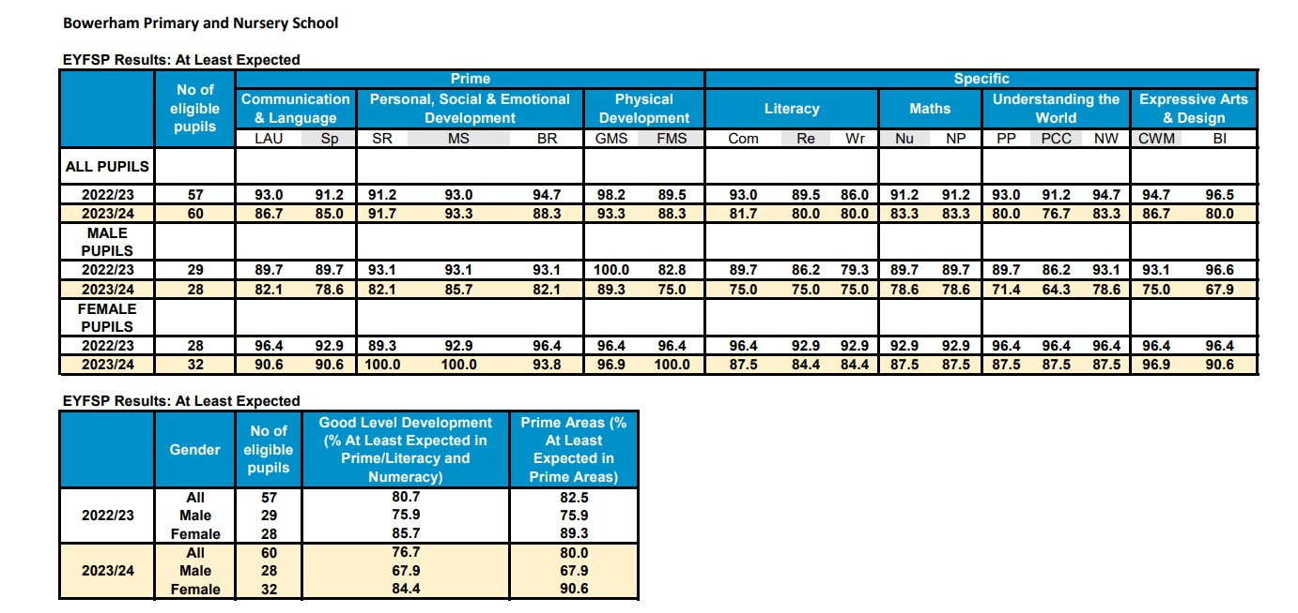

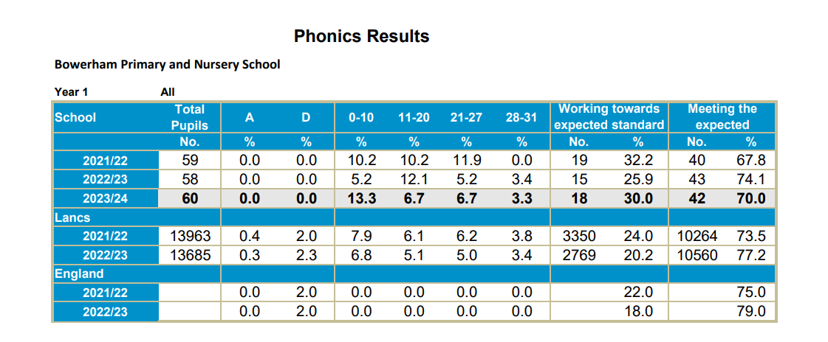

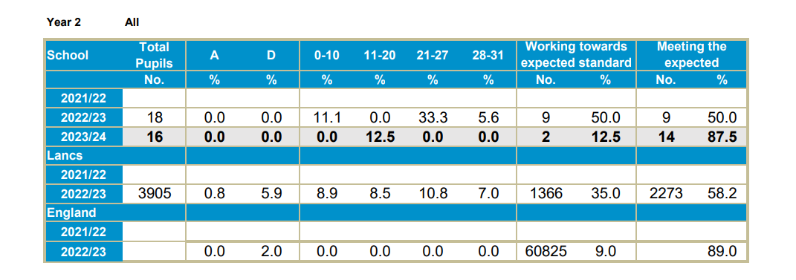

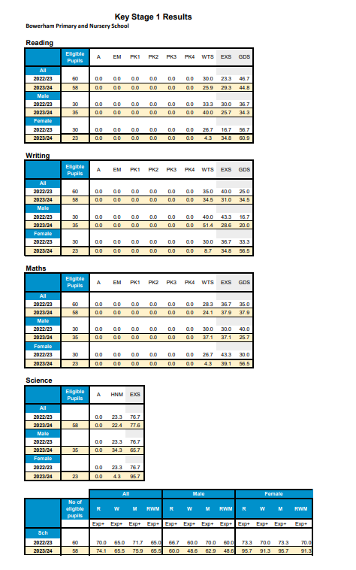

**Multiplication Test Check- Year 4**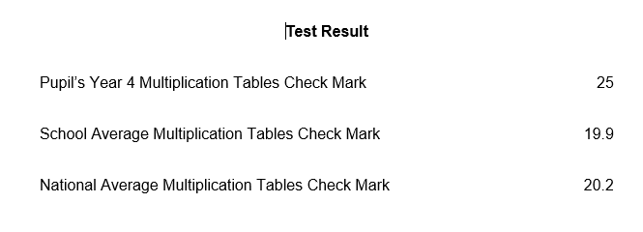

**Year 6 Results**

|  |  |  |  |  |  |  |  |  |  |  |
| --- | --- | --- | --- | --- | --- | --- | --- | --- | --- | --- |
| 23/24 | Reading | | Writing | | GPS | | Mathematics | | Combined RWM | |
| NOR 60 | %  EXS+ | %  GDS | %  EXS+ | %  GDS | %  EXS+ | %  GDS | %  EXS+ | %  GDS | %  EXS+ | %  GDS |
| School TA 24 | 78% | 38% | 82% | 17% |  |  | 80% | 30% | 72% | 12% |
| School Test results | 73% | 20% | 82% | 17% | 78% | 27% | 58% | 30% | 55% |  |
| National headlines3 for 202 | 73% | 29% | 71% | 13% | 72% |  | 73% |  | 59% |  |
| FSM | 60% | 10% | 80% | 10% | 70% | 30% | 30% | 10% | 30% | 10% |
| Average Scaled Score  School | 103 | | N/A | | 105 | | 102 | |  | |
| Average Scaled Score  National 23 | 105 | | N/A | | 105 | | 104 | |

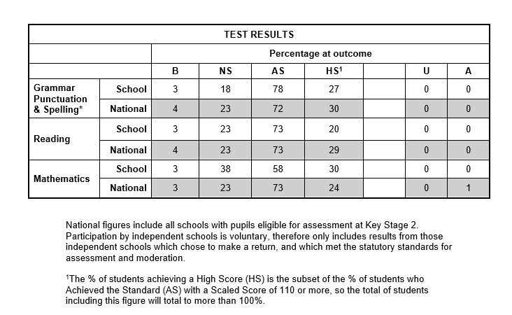

Maths results for Year 6 have been disappointing, partly due to the unexpected five-week absence of the Maths teacher just before SATs. This absence likely impacted the children’s performance, particularly those who were secure in their understanding but struggled in the test environment. These were mostly underconfident girls who had received interventions throughout Key Stage 2. Despite this, teacher assessments indicated that these children were performing at the expected level. In response, the school has set a new target for Maths for the academic year 2024/25 to address this.